ARTIFICIAL INTELLIGENCE IN MINERAL EXPLORATION FOR GRAPHITE: CONCEPTS, METHODS, AND APPLICATION
Gabriel Góes Rocha de Lima
Caetano Juliani
Institute of Goesciences- USP
gabrielgoes@usp.br

Objectives
The goal of this study was to learn the concepts and techniques of computing and Artificial Intelligence, as well as to investigate their potential application in predictive geological mapping and mineral exploration, with a focus on graphite. The project aimed to train students through theoretical and practical learning, which resulted from the creation of a database on their local machine using data from the Geological Service of Brazil's online database (CPRM). The data in this database were processed and analyzed using computational steps written in Python and supervised classification algorithms (Randon Forest - RF and Support Vector Machine - SVM). Predictive lithological maps were created to aid in mineral prospecting, as well as a didactic content of the methods.
Methods and Procedures
Following the identification of the applicable areas, practical studies of interpolation methods and classification algorithms were developed, allowing the creation of a workflow using Python codes to treat the raw data from the aerosurveys. These generated interpolations and the construction of the machine learning algorithm's flowchart aimed at data classification.
The cloud of points resulting from aerosurvey processing is not regularly distributed due to gps errors in the air survey, conditioned on the number of ground stations, as well as sampling with much higher frequency along the flight lines, when compared to the distances between the lines. This spatial irregularity in data sampling prevents many data processing methods from being successfully completed, resulting in the aliasing effect error, which is produced when interpolating a data sampled more frequently in one direction than in another, generating straight and parallel lines along the overshown axis, hindering interpretation and generating artificial lineage in the images (Uieda, 2018).
It was possible to correct both the problem of spatial irregularity of sampling and the problem of large distances between sampling points in aerogeophysical surveys using the Green’s function interpolation technique. The regression model was created using a function that describes the behavior of the values between the sampled values, and a variable that describes how sharp the curves will be, which is the degree of the polynomial function to be generated.
The Random Forest method was used for training with orange software. Following processing, the data obtained through interpolation was transformed from images using .netCDF from a .csv data table, and the correlation matrix and histogram of the data were created.

Results
The results of the pre-processing stage of the São Paulo - Rio de Janeiro Project (CPRM) aerogeophysical survey were concatenated in a GeoDataFrame for classification by random forest algorithm with orange software. Figure 1 depicts the plot of data interpolated by the Cubic method on a 1000 m regular grid.
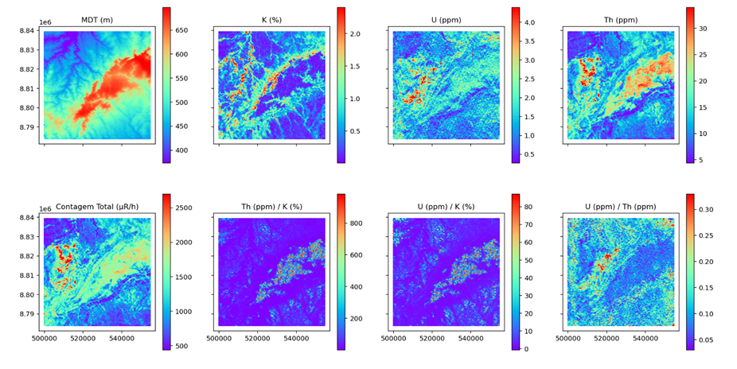
Figure 1: Plot of data interpolated by the Cubic method on a 1000 m regular grid.

Figure 2 depicts the Randomize Forest supervised classification in action in the test area.
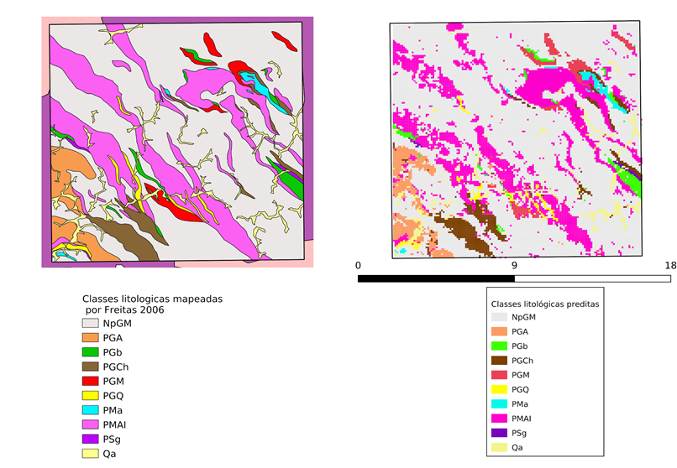
Figure 2: Random Forest classification of the geology of the Caconde region (SP) (on the right), based on the map by Freitas (2016) (on the left). Due to their small dimensions, it is impossible to distinguish the graphite bodies when verifying excellent mapping results.

The Support Vector Machine method was used to perform supervised classification training in the Socorro (SP) region using 1:25,000 geological map produced by Freitas (2016). The processing results are less satisfactory when compared to the Randon Forest method, but they still have great application potential, depending on the scale of the geological surveys and maps and, most importantly, the quality of the aerogeophysical surveys.
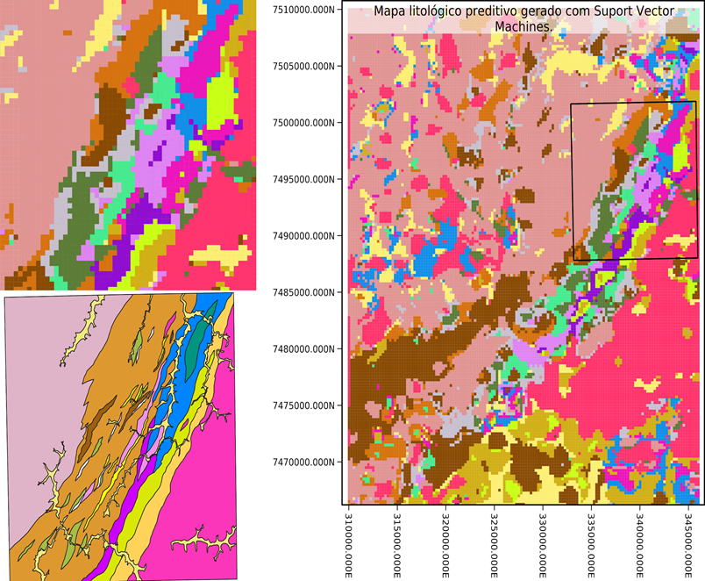
Figure 3: Predictive lithological map of the Socorro region created with the aerial survey "1039" and supervised by the Freitas geological map (2006). (SP). The predictive lithological map is depicted in the large image on the right.

Conclusions
The development of this Scientific Initiation project allowed for intensive training of the scholarship holder, as well as a preliminary definition of the potential for application of Artificial Intelligence tools in Geosciences, particularly for the elaboration of predictive geological maps, resulting in a significant increase in map quality and cost savings. However, because of the scale of the aerogeophysical surveys and graphite bodies, which can only be delimited on larger-scale maps (Freitas, 2016), the processing did not allow for their identification and accurate mapping using RF and SVM methods.

Bibliographic references
Freitas, F.C. (2006) Evolução metamórfica dos terrenos granulíticos de Socorro, Caconde (SP) e Cambuí (MG). Programa Pós-Graduação em Mineral. e Petrol., p. 259.
Uieda, L. (2018). Verde: Processing and gridding spatial data using Green’s functions. Journal of Open Source Software, 3(30), 957

